Sign up
- Click “Sign up” button.
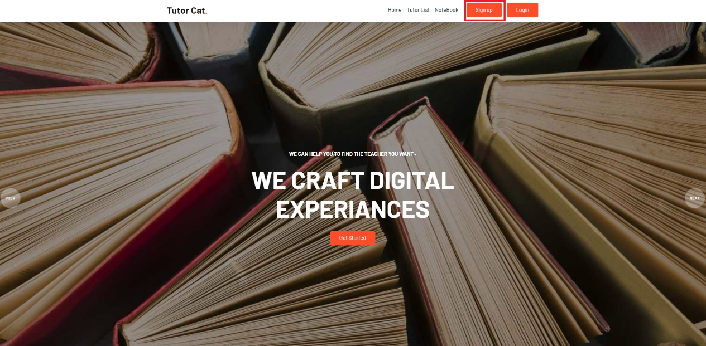
- Select one option of the set (student / tutor) to sign up.
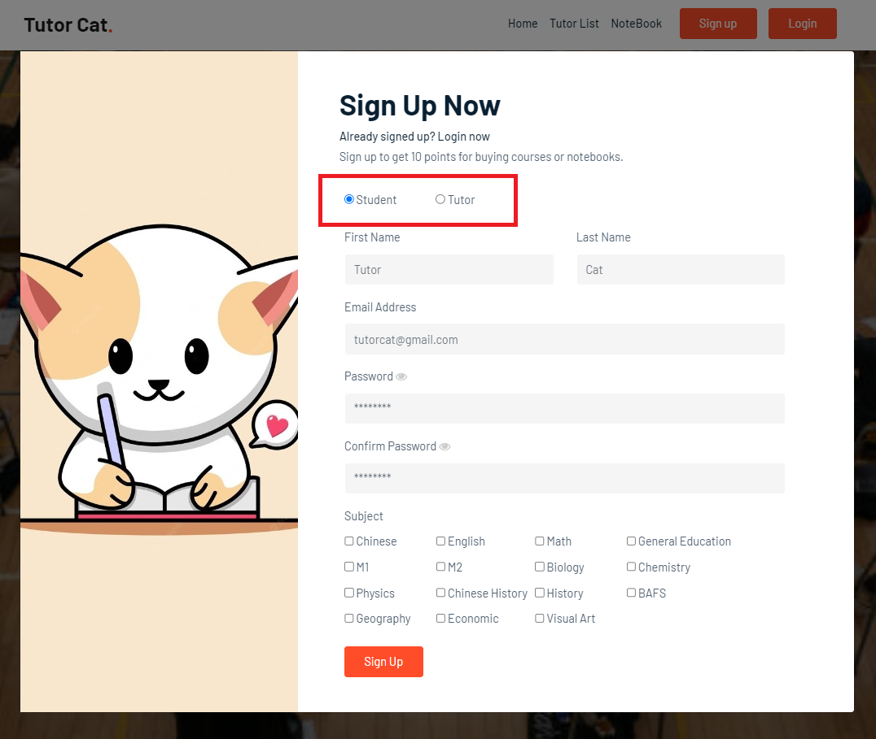
- Input required information such as name, email, password, etc…
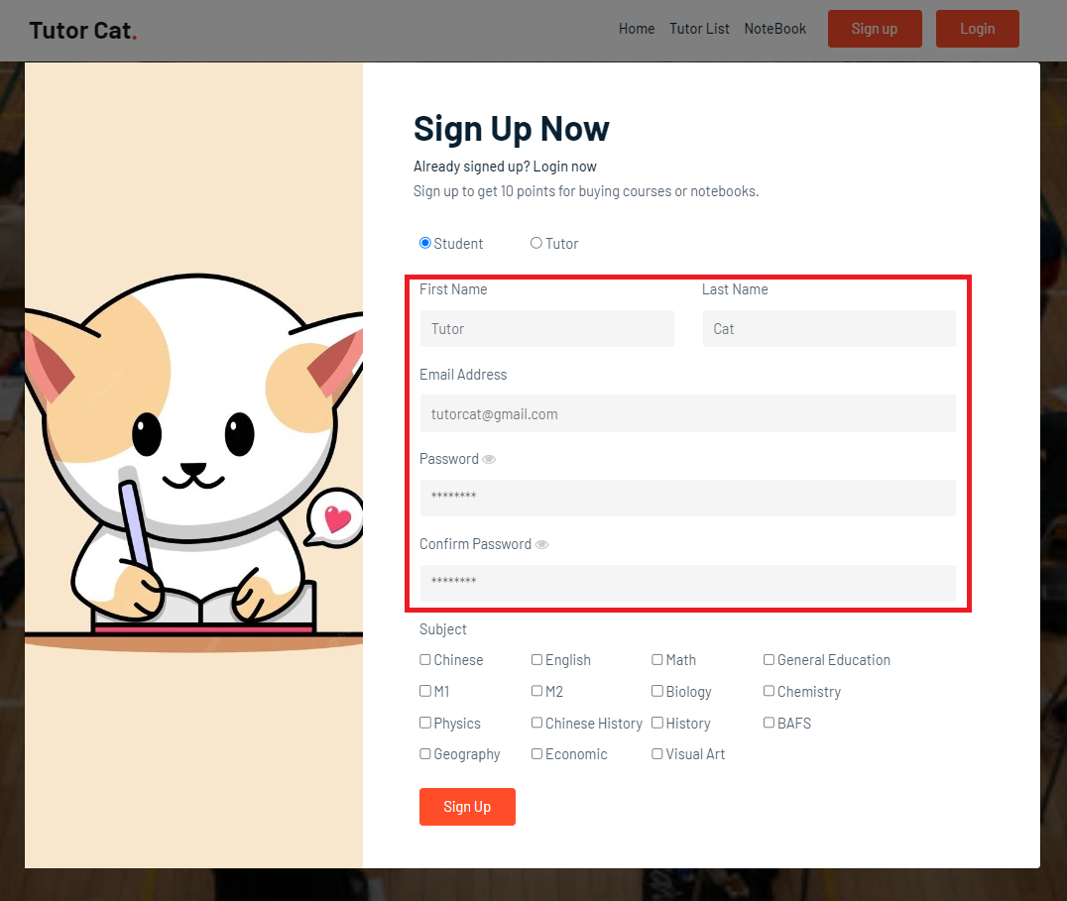
- Select one or more subjects for the courses or notes you would like to buy.
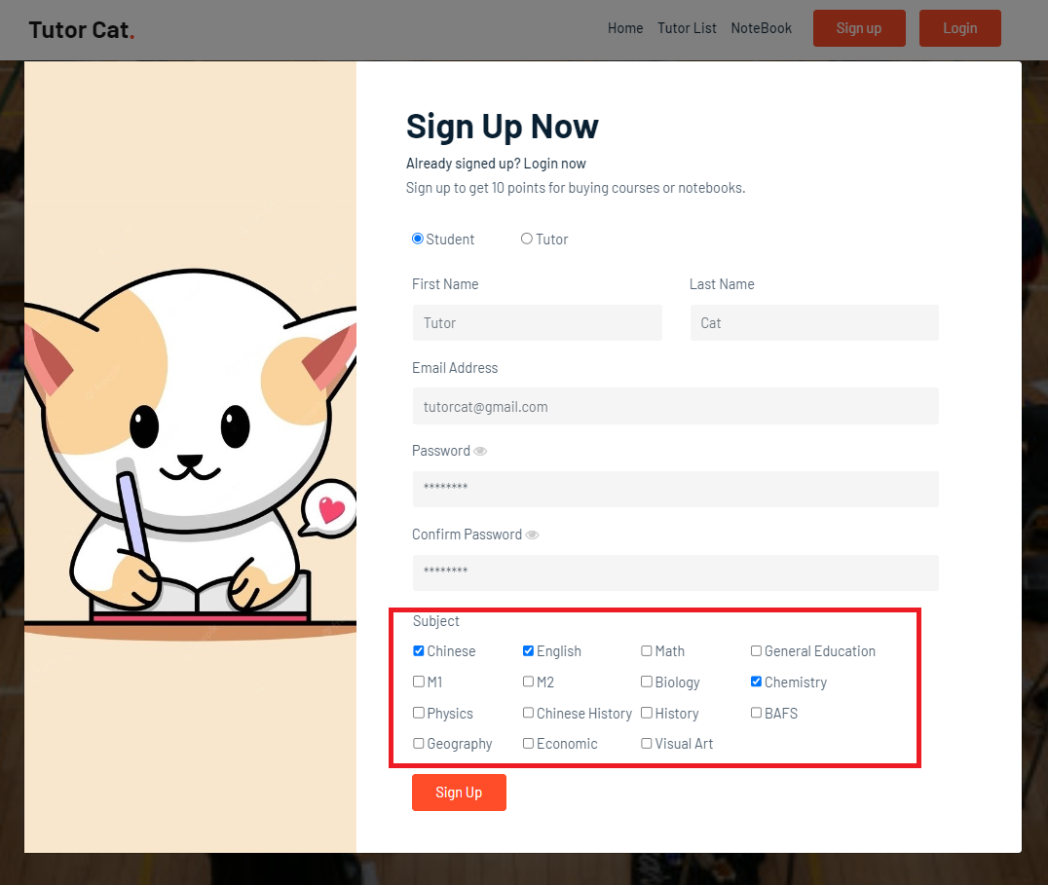
- Click “Sign up” button after input all information.
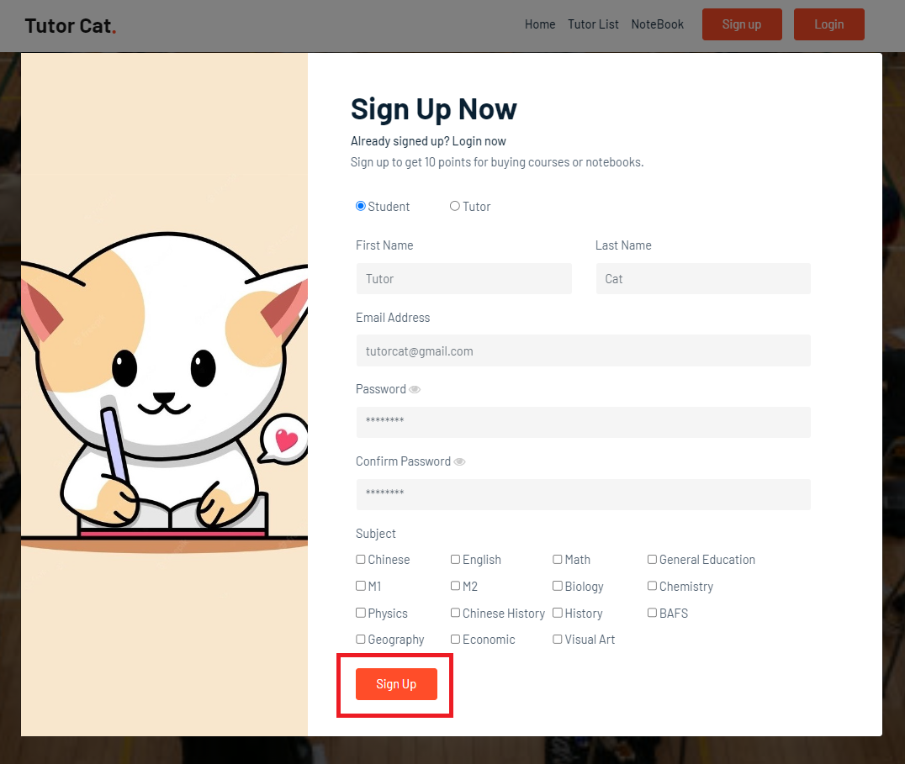
- It will show an alert message after account created and switch to login page.
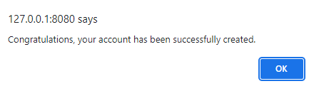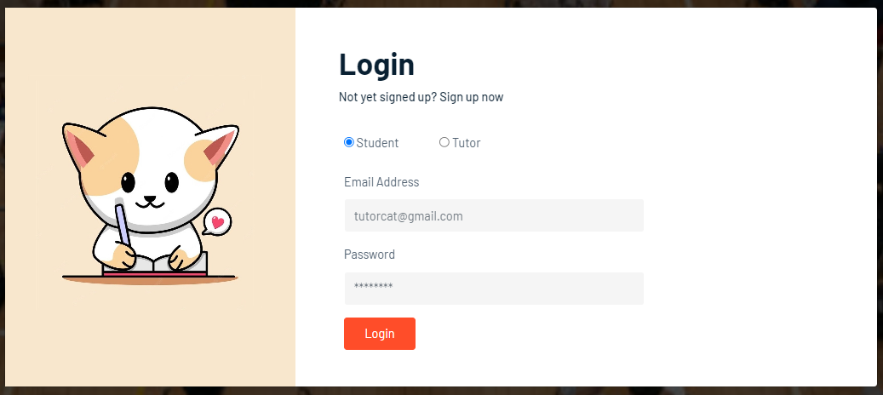
Login
- Click “Login” button.
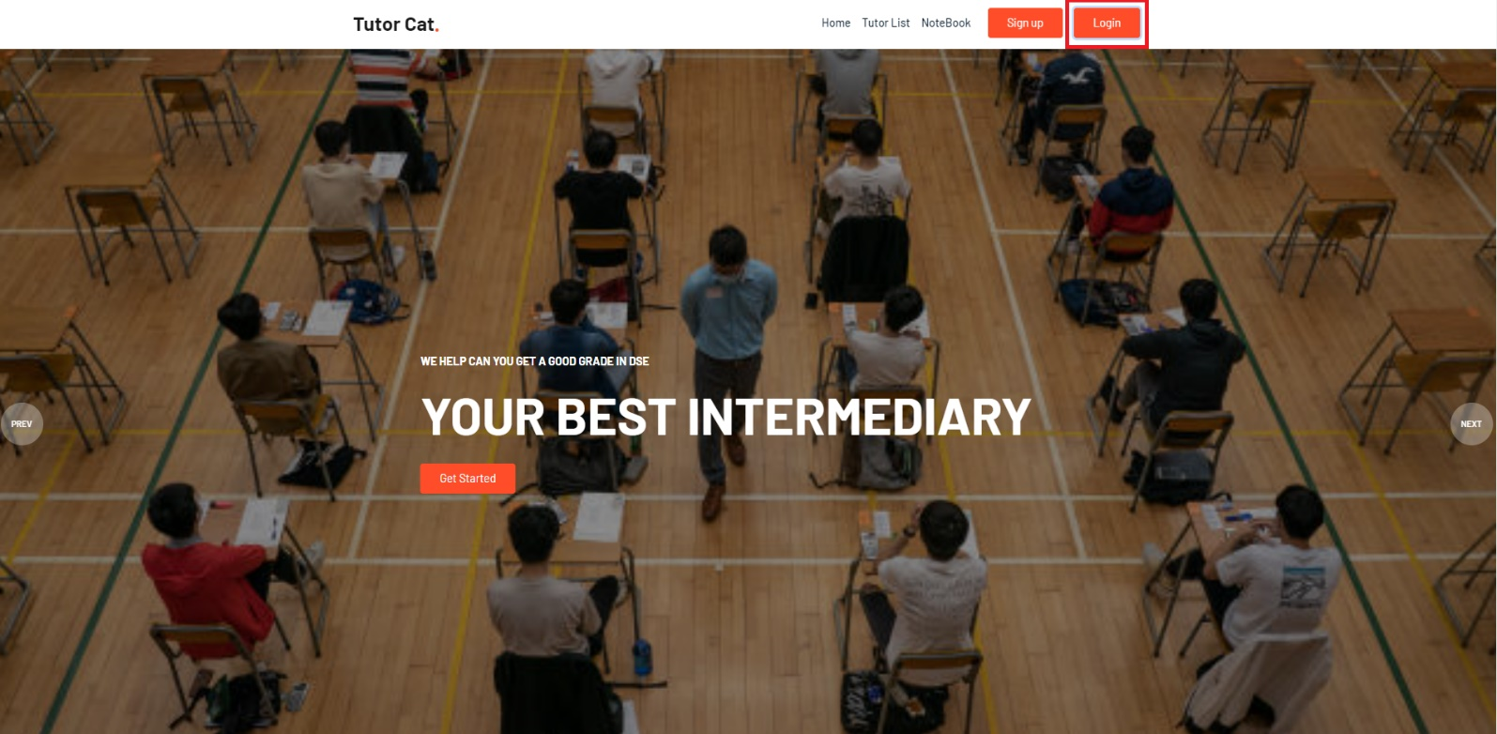
- Select one option of the set (student / tutor) to login.
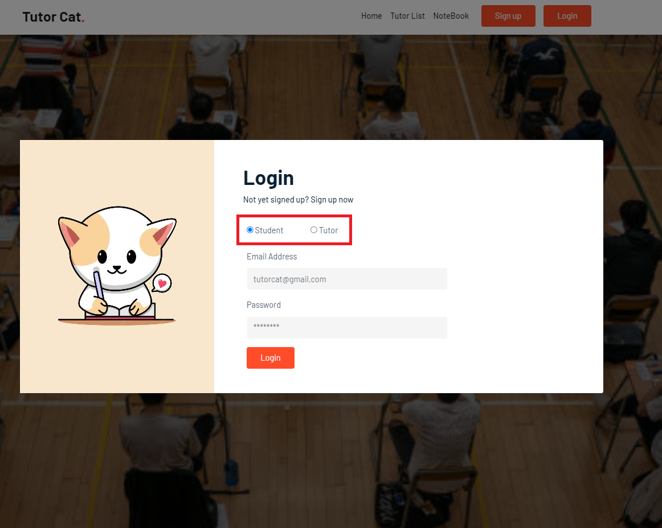
- Input email address and password.
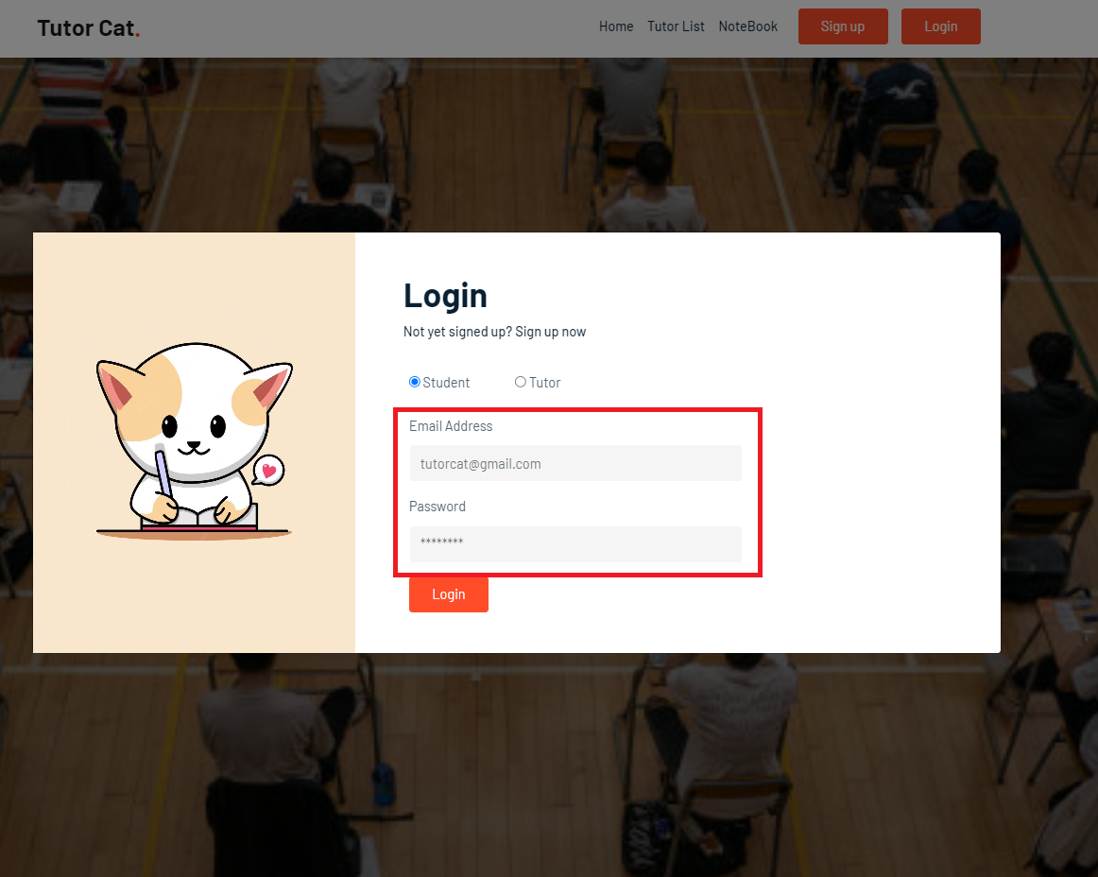
- Click “Login” button.
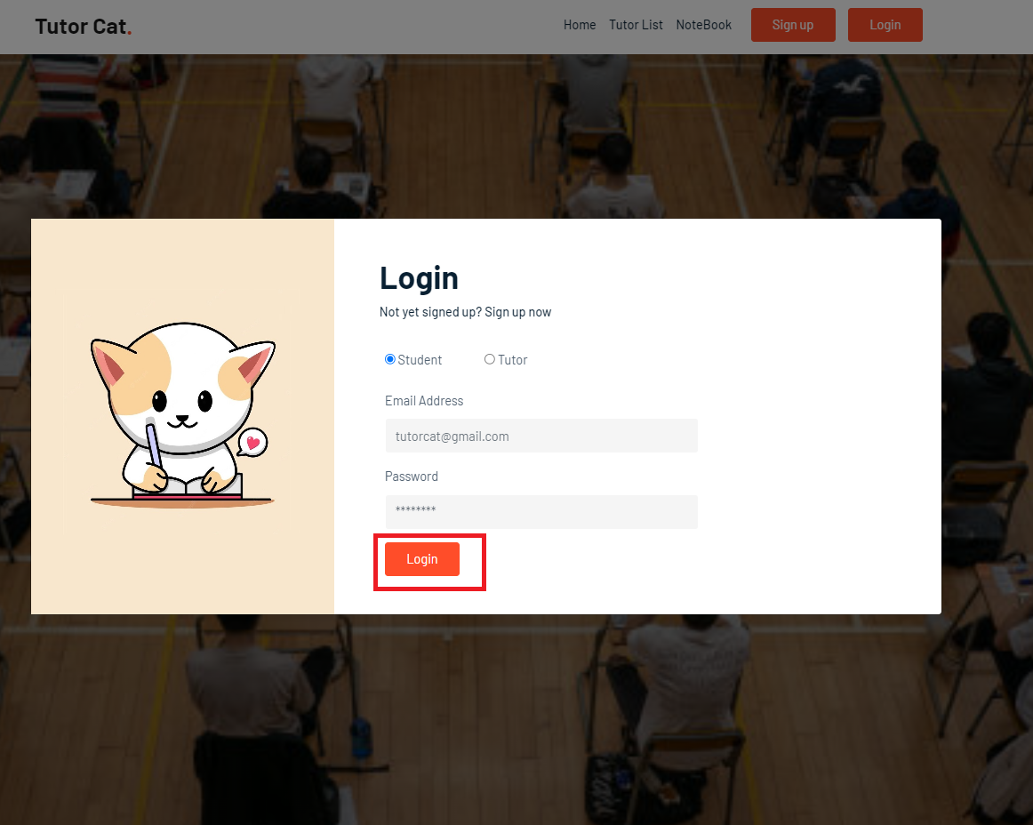
- After login, it will show a profile button, your name, point, chat room button and logout button.
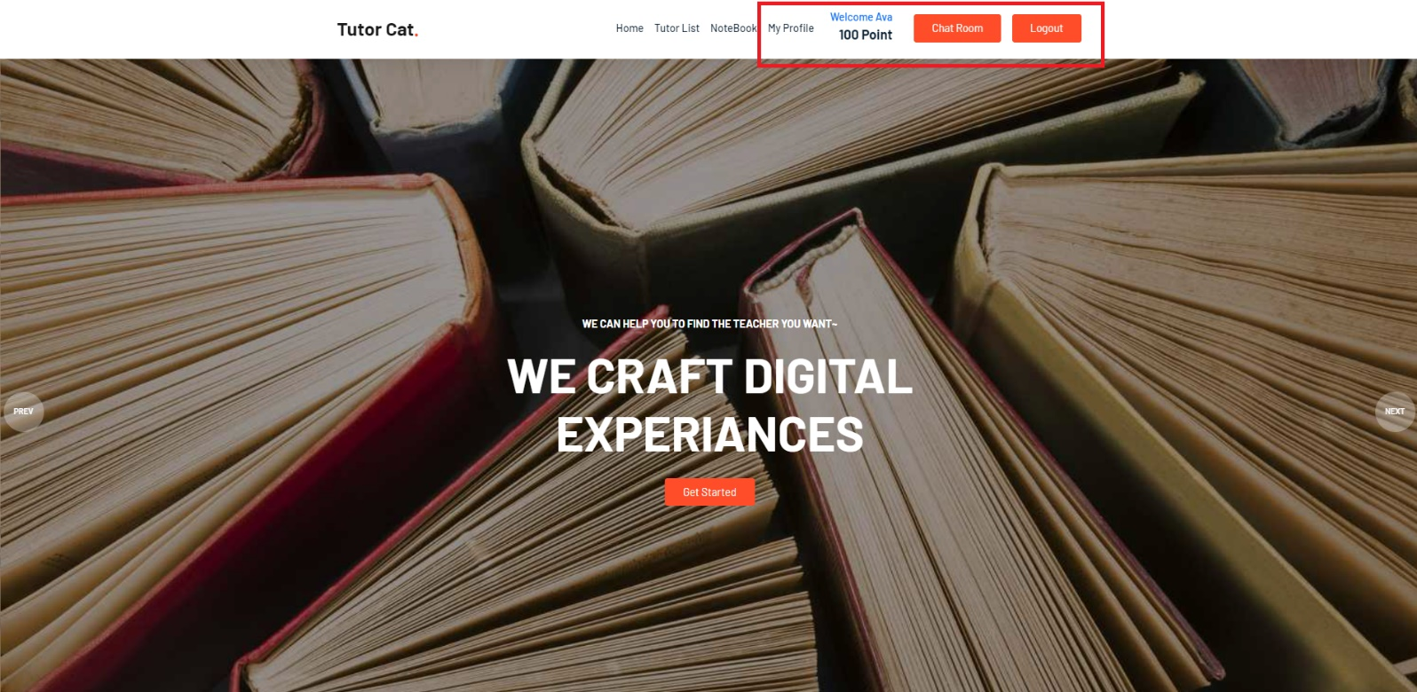
Chat room
- Click “Chat Room” button.
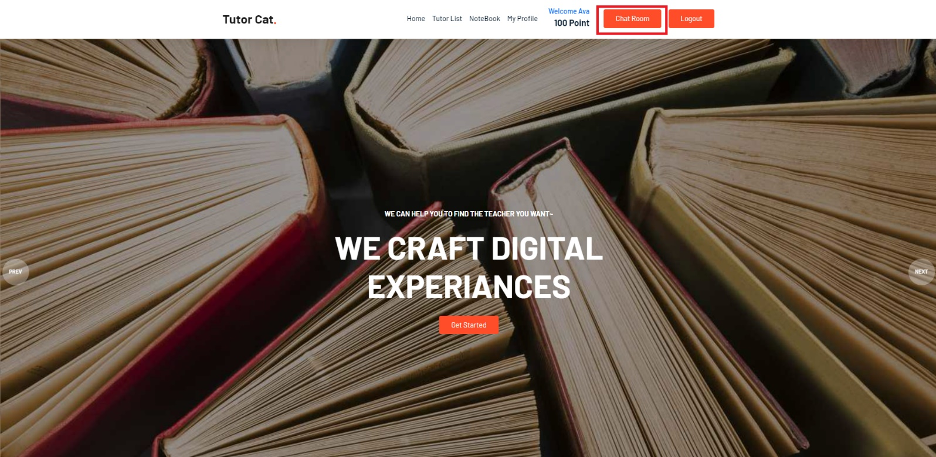
- Click on the tutor / student name on the left to start the chat.
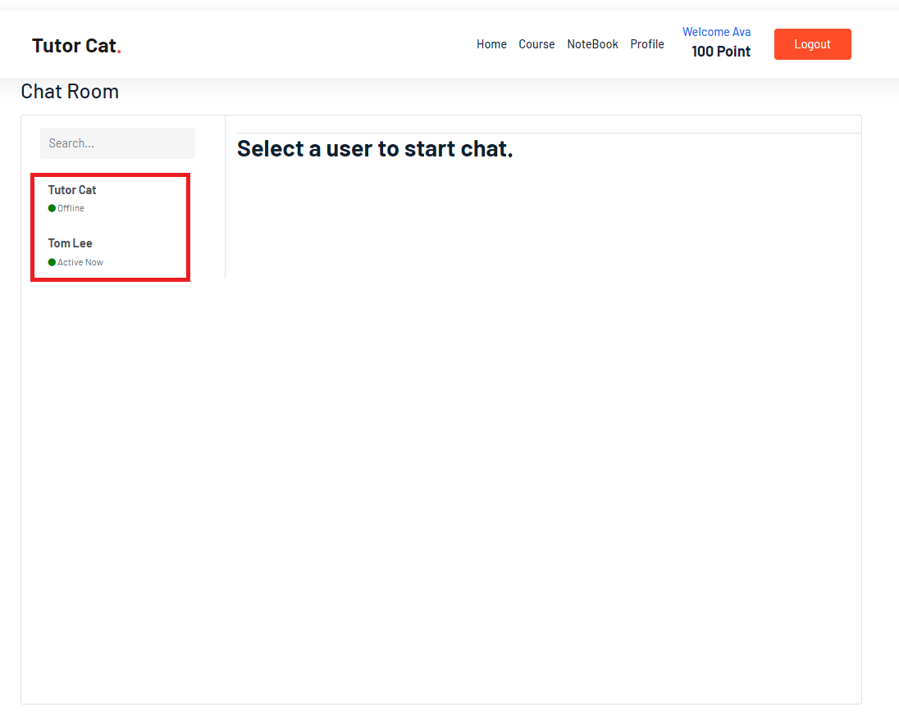
- User can type text message in the text box.
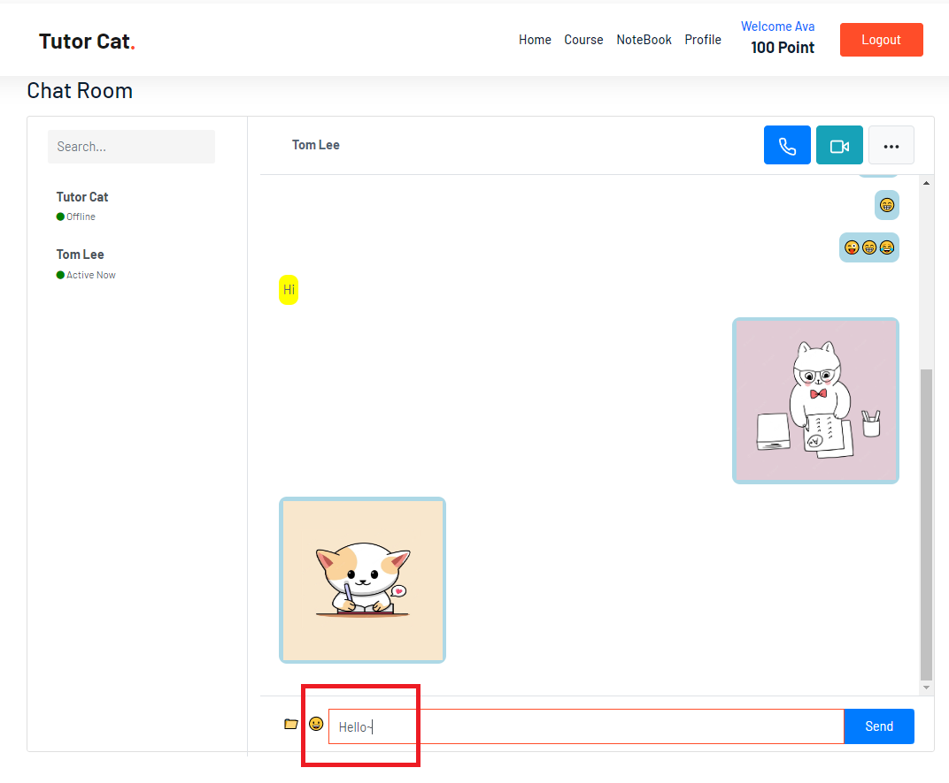
- Click “Emoji” icon and select emoji to send.
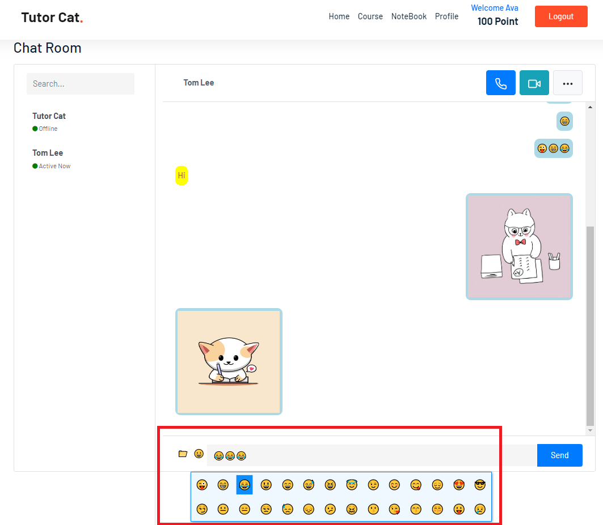
- Click “Send” button to send the message.
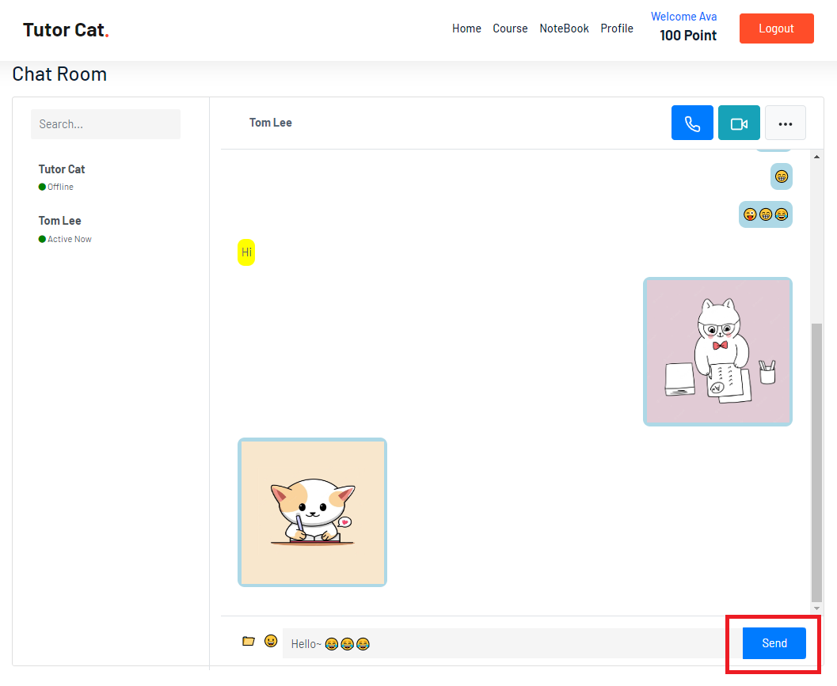
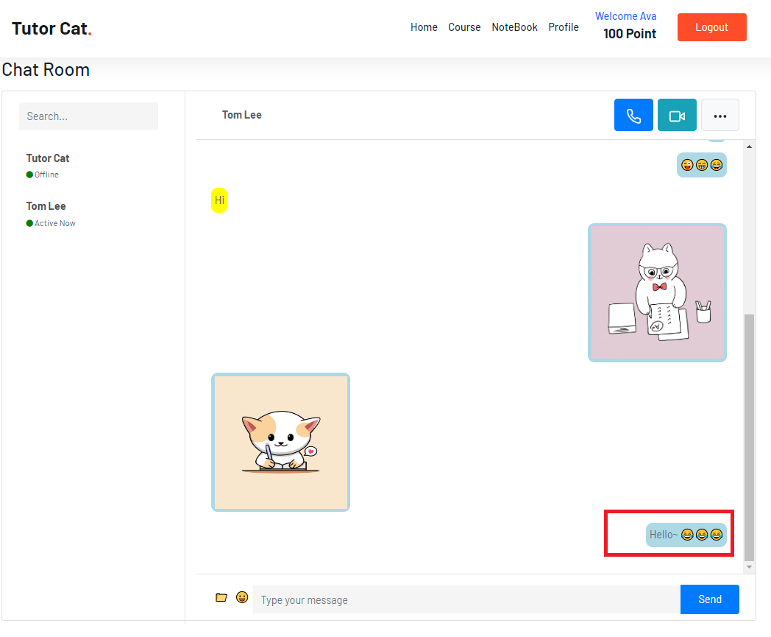
- Click “File” icon to send file.
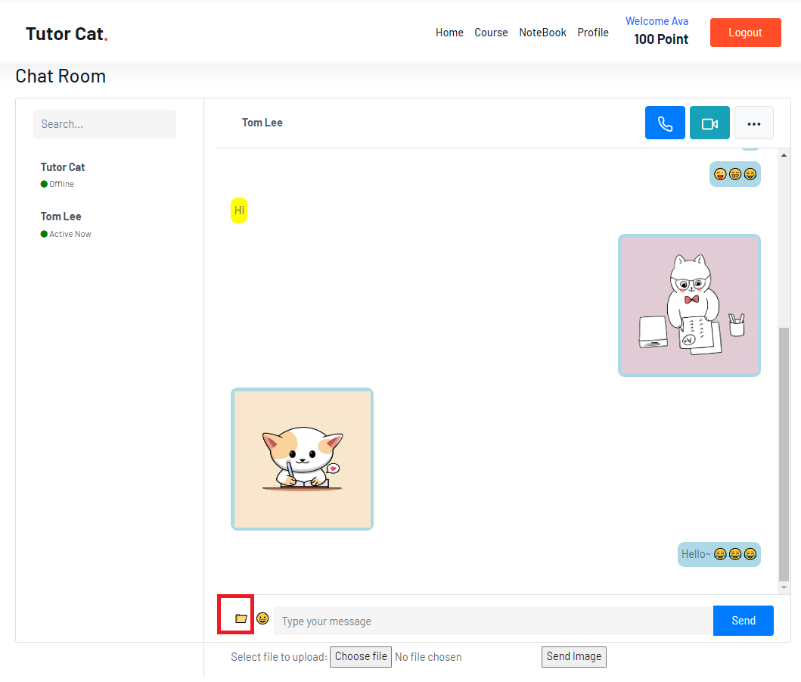
- Click “Choose file” button to upload file.
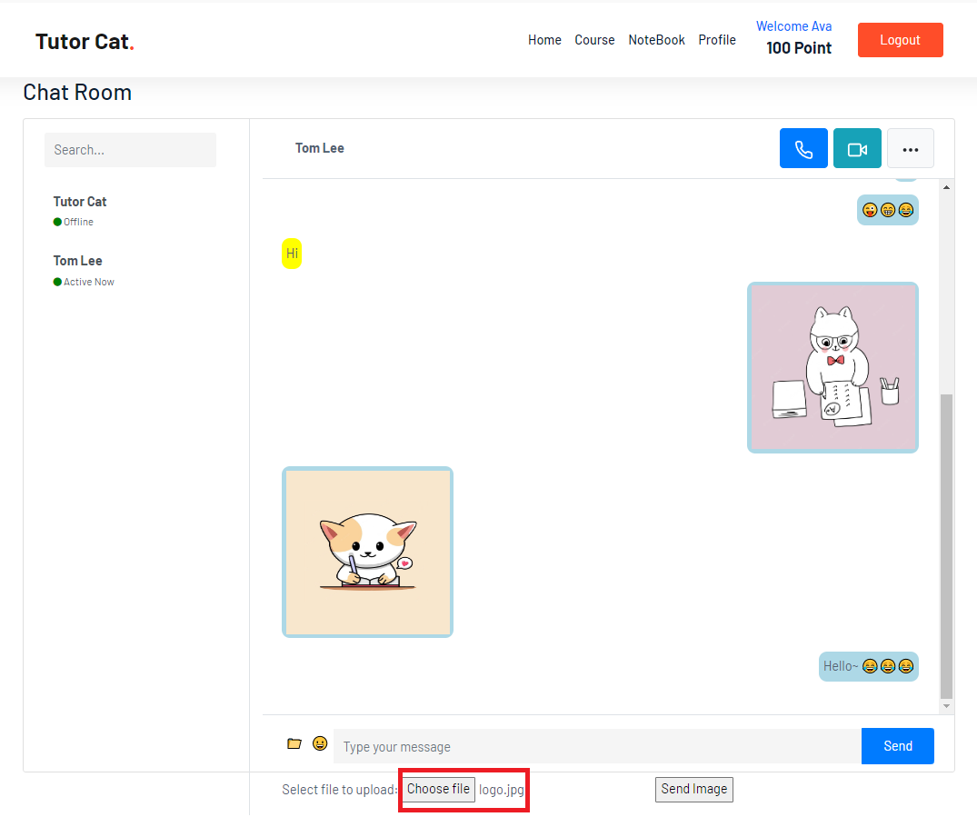
- Click “Send Image” button to send file.
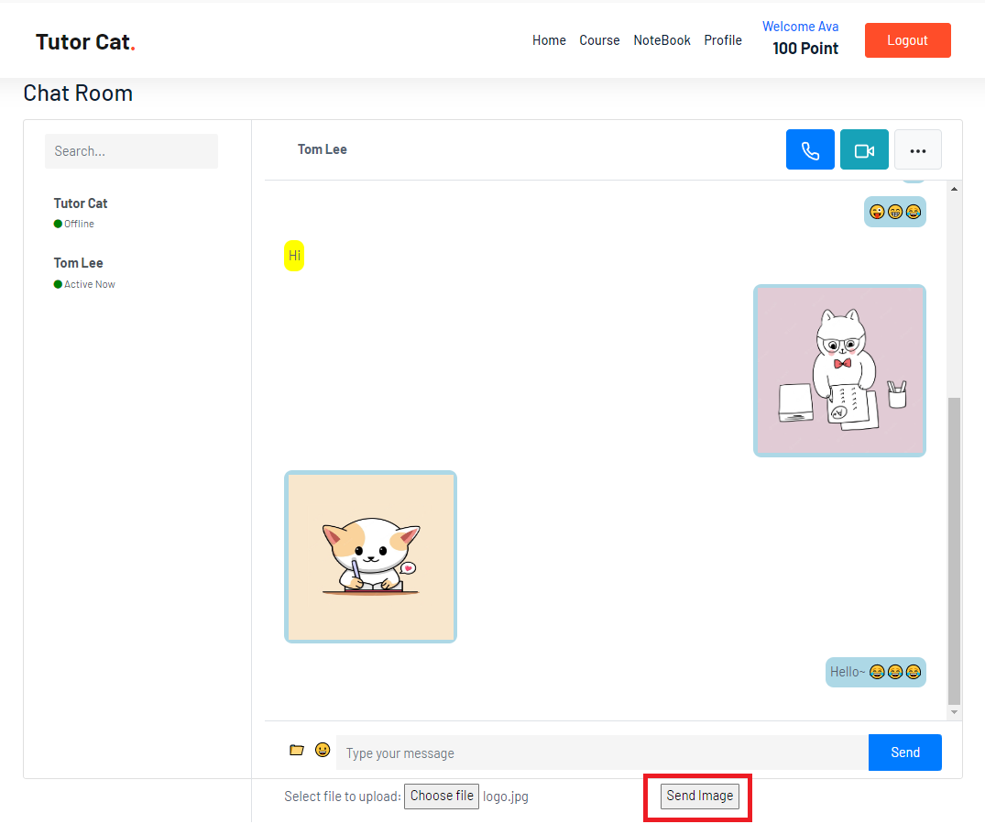
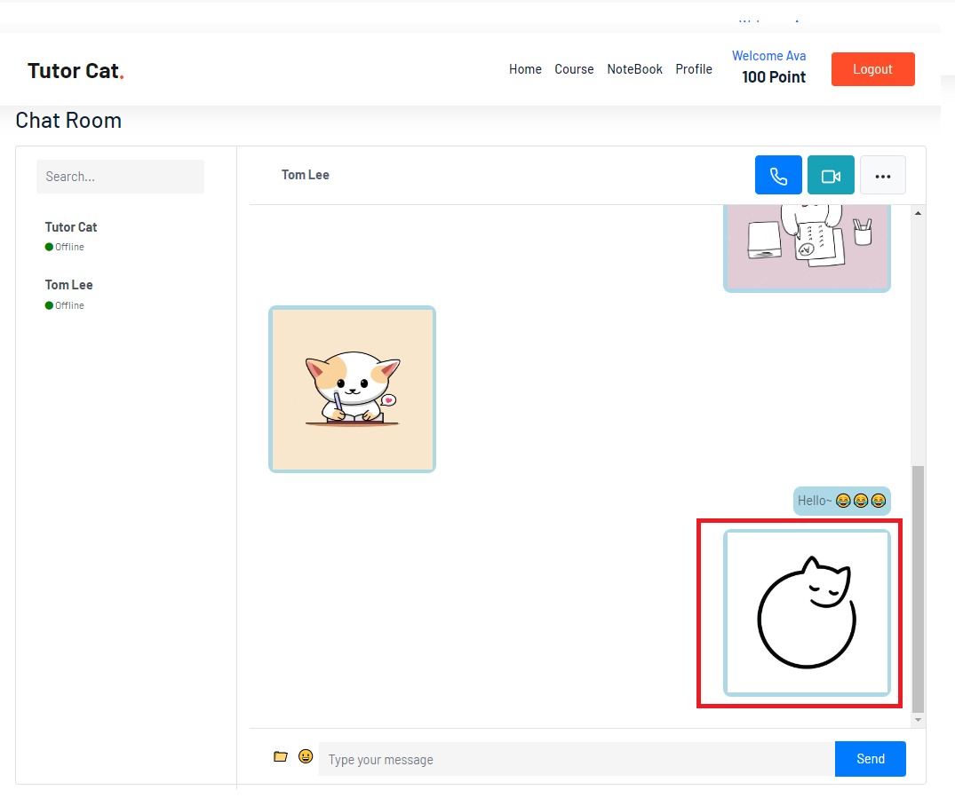
Paypal Payment
- Select one option of the set (payment method) to pay the course or note.
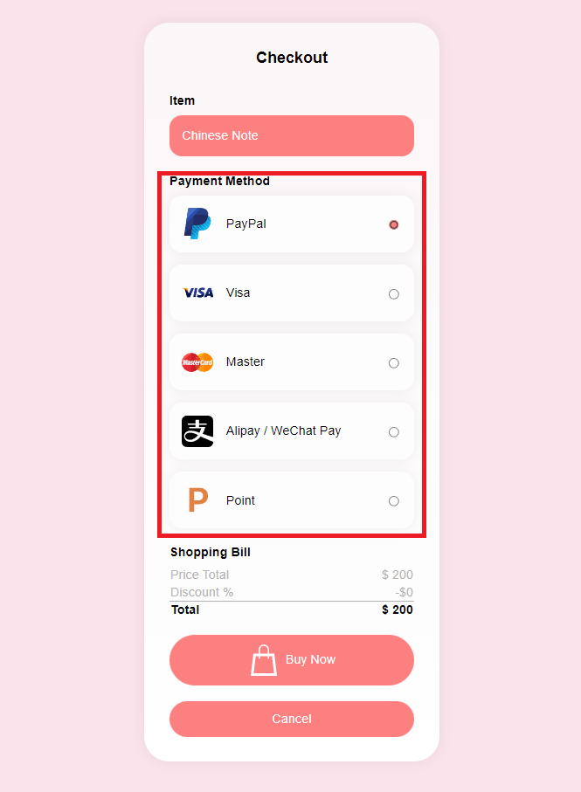
- If you select paypal, it will redirect to paypal website. Enter email and password to login.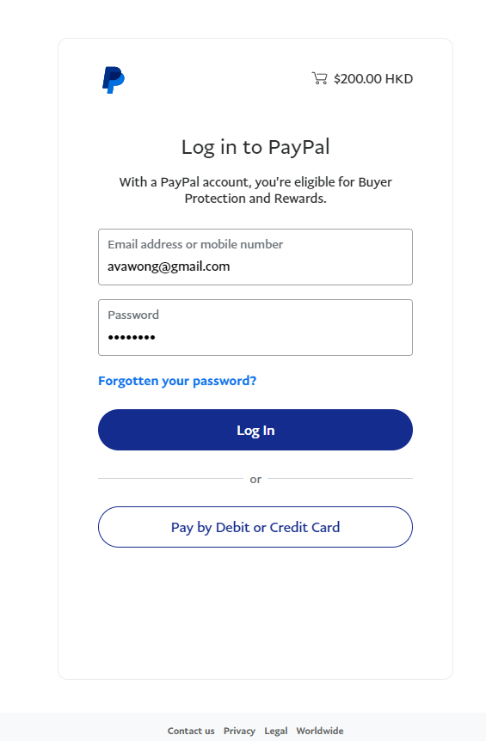
- Click “Complete Purchase” to pay.
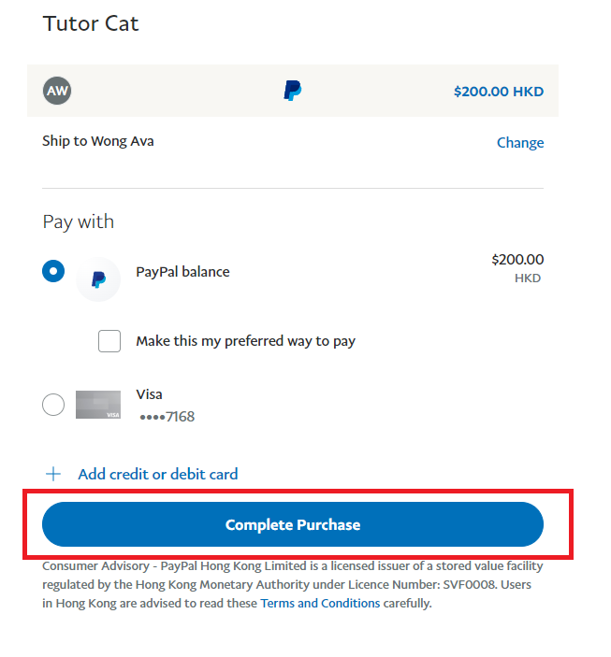
- After payment completed, it will show an alert message with purchase information and point you have earned.
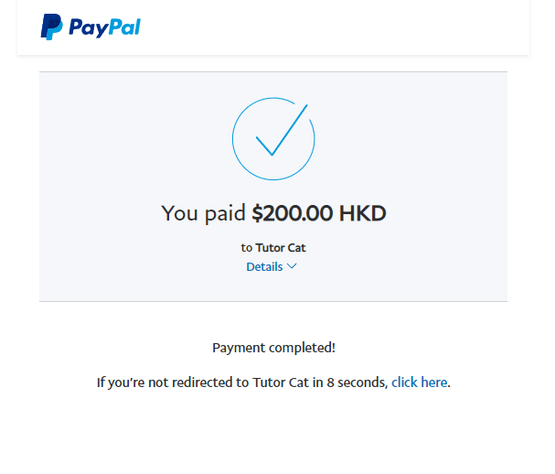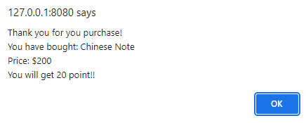
Credit Card Payment
- Select Visa / Master payment method.
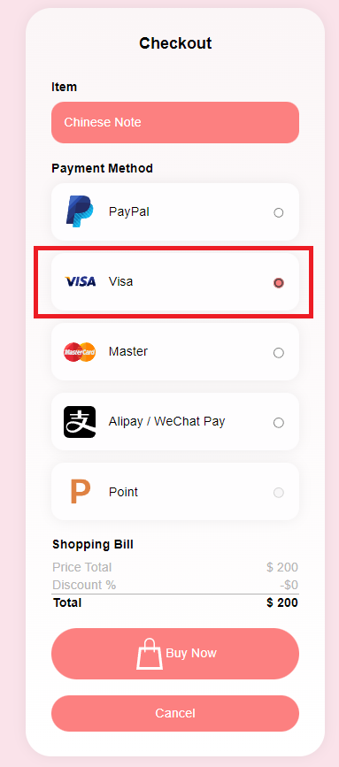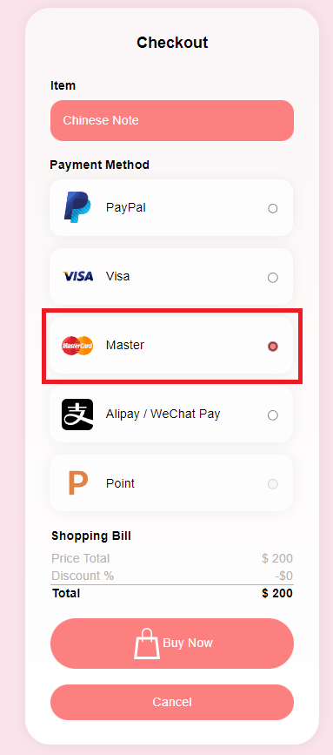
- Enter email and credit card information
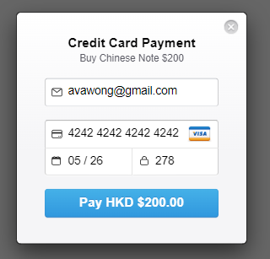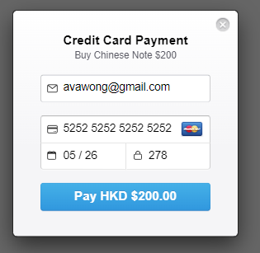
- Click “Pay” button to pay.
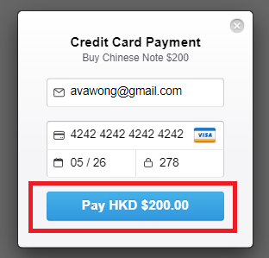
- After payment completed, it will show an alert message with purchase information and point you have earned.
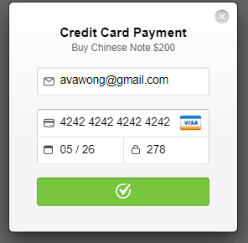
Alipay / WeChat Pay Payment
- Select Alipay / WeChat Pay payment method.
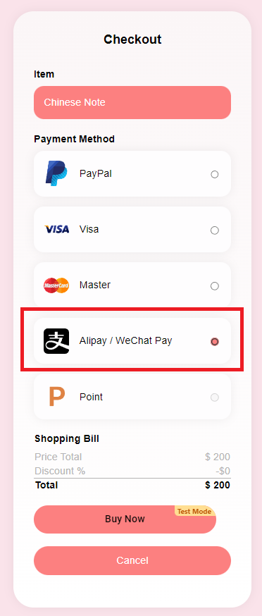
- Click “Alipay” / “WeChat” button.
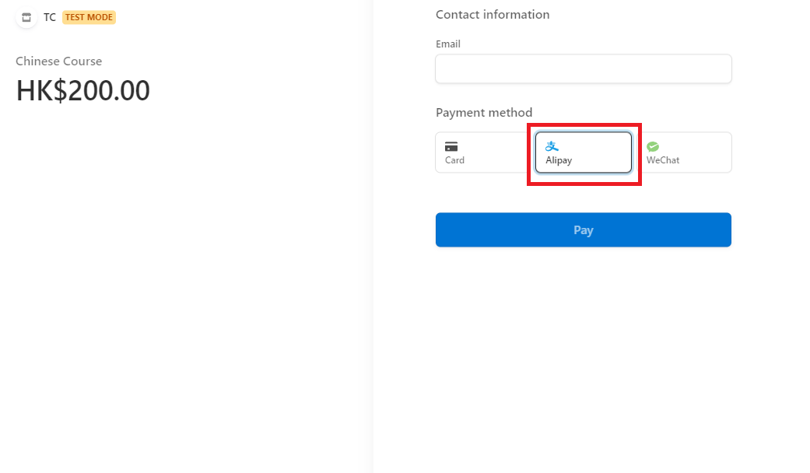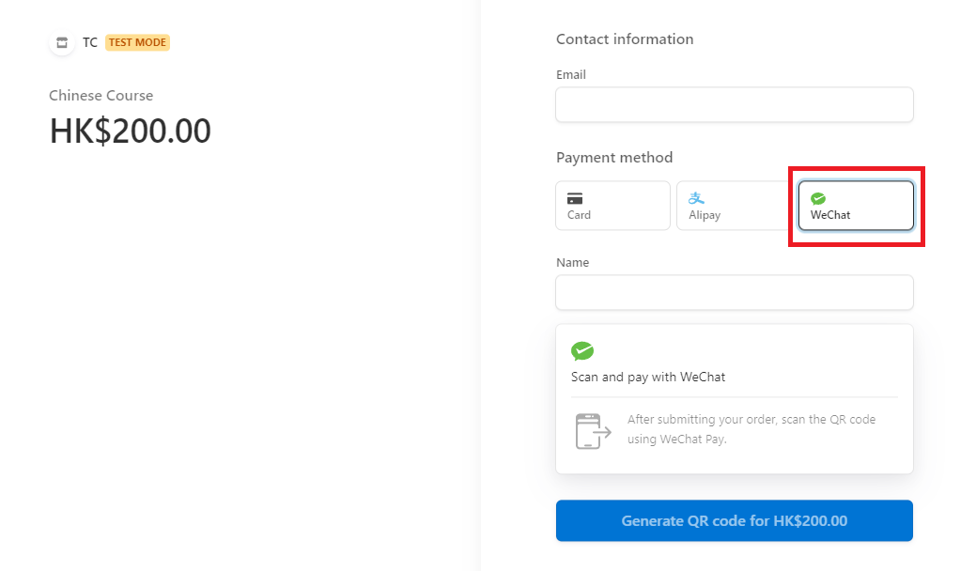
- Enter email address to pay with Alipay or WeChat Pay to get the QR code.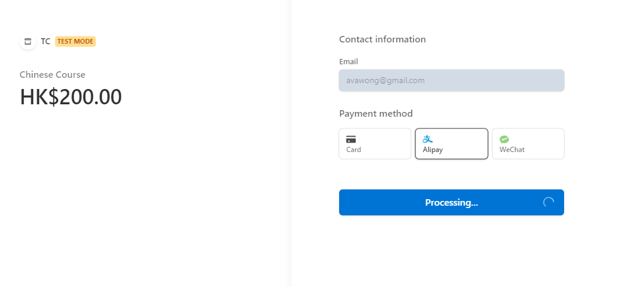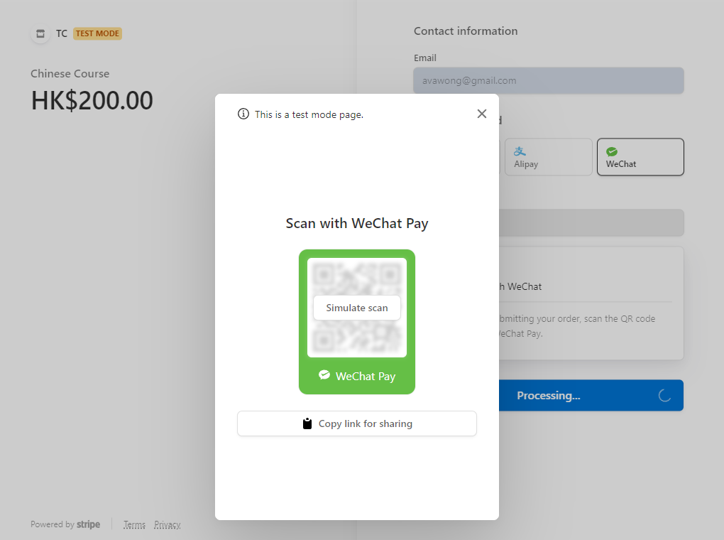
- After payment completed, it will show an alert message with purchase information and point you have earned.

Point Payment
- Select Point payment method. It will show how many point left after paying with point.
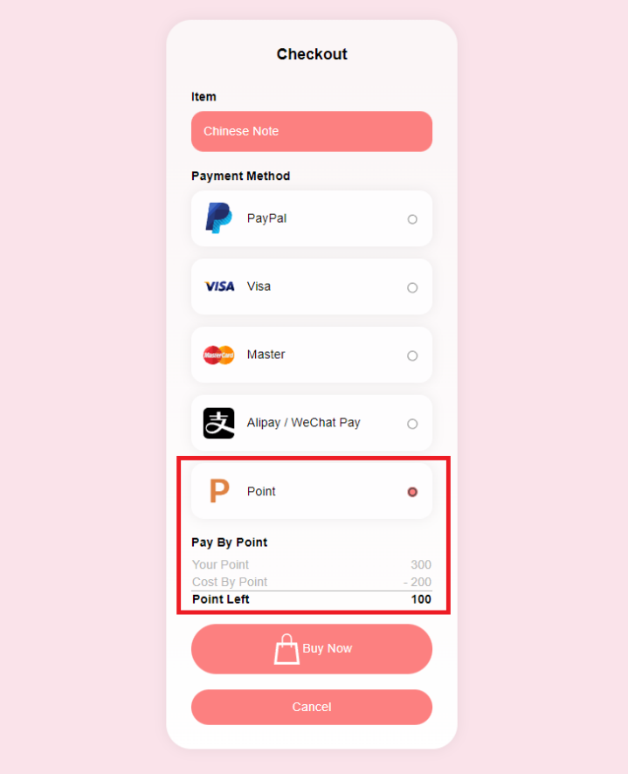
- Click “Buy Now” button to pay.
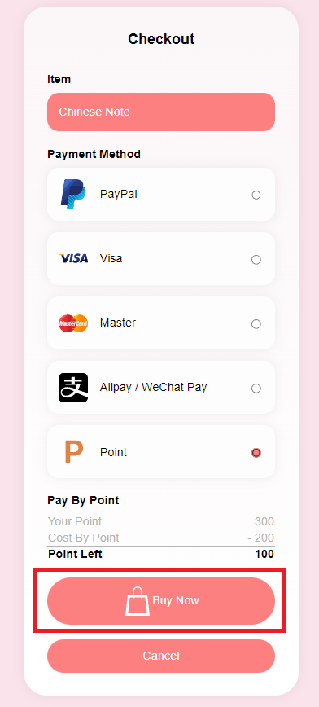
- After payment completed, it will show an alert message with purchase information and point left.
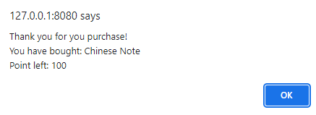
- An alert message will be shown if you have insufficient point and the point button is disabled.
